**Course: Advance Bio Informatics**

**Module Title: Cloud Computing**

**Module No: 139**

**Definition:**

“Cloud computing is defined as a type of computing that relies on sharing computing resources rather than having local servers or personal devices to handle applications.”

Cloud computing is comparable to grid computing, a type of computing where unused processing cycles of all computers in a network are harnesses to solve problems too intensive for any stand-alone machine.

In cloud computing, the word cloud (also phrased as "the cloud") is used as a metaphor for "the Internet," so the phrase cloud computing means "a type of Internet-based computing," where different services — such as servers, storage and applications — are delivered to an organization's computers and devices through the Internet.

**How Cloud Computing Works**

The goal of cloud computing is to apply traditional supercomputing, or high-performance computing power, normally used by military and research facilities, to perform tens of trillions of computations per second, in consumer-oriented applications such as financial portfolios, to deliver personalized information, to provide data storage or to power large, immersive online computer games.

To do this, cloud computing uses networks of large groups of servers typically running low-cost consumer PC technology with specialized connections to spread data-processing chores across them. This shared IT infrastructure contains large pools of systems that are linked together. Often, virtualization techniques are used to maximize the power of cloud computing.

**Characteristics**

* Pooled resources:
* Elasticity
* Automation
* Metered billing

**What is cloud computing?**

Computing as a service is doing over the Internet. Cloud computing is using the internet to access someone else's software running on someone else's hardware in someone else's data center. Cloud computing, often referred to as simply “the cloud,” is the delivery of on-demand computing resources—everything from applications to data centers—over the Internet on a pay-for-use basis.

**Software as a Service (SaaS)**

Cloud-based applications—or software as a service—run on distant computers “in the cloud” that are owned and operated by others and that connect to users’ computers via the Internet and, usually, a web browser. IBM Cloud is used software as a service.

**Benefit of SAAS**

You can sign up and rapidly start using innovative business apps. Apps and data are accessible from any connected computer. No data is lost if your computer breaks, as data is in the cloud. The service is able to dynamically scale to usage needs. Cloud computing SaaS. With SaaS, you no longer have to purchase, install, update and maintain the software.

**Platform as a Service (PaaS)**

Platform as a service provides a cloud-based environment with everything required to support the complete lifecycle of building and delivering web-based (cloud) applications—without the cost and complexity of buying and managing the underlying hardware, software, provisioning and hosting.

IBM Cloud platform as a service

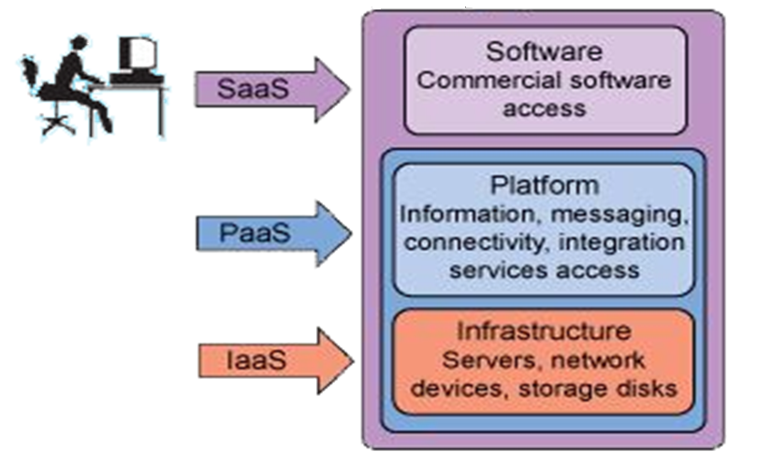

**Benefit of PAAS**

Develop applications and get to market faster. Deploy new web applications to the cloud in minutes. Reduce complexity with middleware as a service. Deploy and migrate applications to both public and private clouds.

**Infrastructure as a Service (IaaS)**

Infrastructure as a service provides companies with computing resources including servers, networking, and storage and data center space on a pay-per-use basis.

IBM Cloud infrastructure as a service

**Benefit of IAAS**

No need to invest in your own hardware. Infrastructure scales on demand to support dynamic workloads. It provides flexible, innovative services available on demand. Cloud computing IaaS Get up and running more quickly while cutting costs.

